

brunch menu

SMALL DISHES AND SALADS TO SHARE

Kolotsi farm goat cheese cream
roasted beetroot / pickled kohlrabi / coriander butter roasted hazelnuts / crispy crispbread

Blin with cold-smoked salmon tartare
sour cream with dill / chives / red onion

Veal roasted with lemon and rosemary
black garlic mayo / crispy onion / crunchy cheese
MAIN COURSE – INDIVIDUAL

Belle Époque breakfast
The elegance and refinement of the Art Nouveau era on a plate – poached egg / toasted ciabatta / avocado / chili flakes / roasted pumpkin seeds

Or

Roasted duck breast
caramelised pear /parsnip-pear cream/ spiced carrot caviar / sea buchthorn sauce

Or

Crispy pike perch with greaves
Blackened leek / potato-parsley cream / roosted cauliflower and romanesco / butter sauce
DESSERT – INDIVIDUAL

Crispy sea buckthorn cheesecake with salted caramel
Peanutt granola/ vanilla ice cream / sea buchthorn sauce
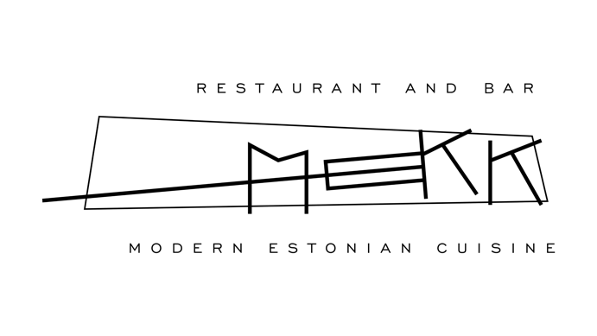

Chef de Cuisine – Rene Uusmees

